This week we finalised the connection to aws to the UI flow alongside with creating a new pipeline to follow:
Ui- flow to aws connection:
there were a couple of trials and errors we tried along the way, we initially tried of by using micro python in UI flow 2 to connect then realised it wouldn’t work in an orderly manner. After which then we switched over to UI flow 1.18. Ui flow 1.18 was the older version but had a lot more documentation and was easier to connect in comparison to Ui flow 2.0 . After which we then headed over to try Blocky instead as an alternative to connect our AWS to the sensor codes we tried in the micro python beforehand. In the past 2 weeks we spend a lot more time ensuring the sensors data was accurate while still figuring out what connectivity works best for AWS.
Final step for aws connection
1) swap from UI flows 2.0 to UI flow 1.18
2) swap from micro python to blocky
3) establish clear signs of labels and sensors for identification
4) Add in blocky connection into aws iot
5) open aws iot in AWS
6) Go into aws iot and create a “thing” it should be under “all devices”
7) while creating a new thing keep in mind of

Establishing the aws pipeline:
For the aws pipeline there were a couple of thought processes that were looked into while there were a few options that we considered to be our final pipeline before settiling for the final result
Option 1:
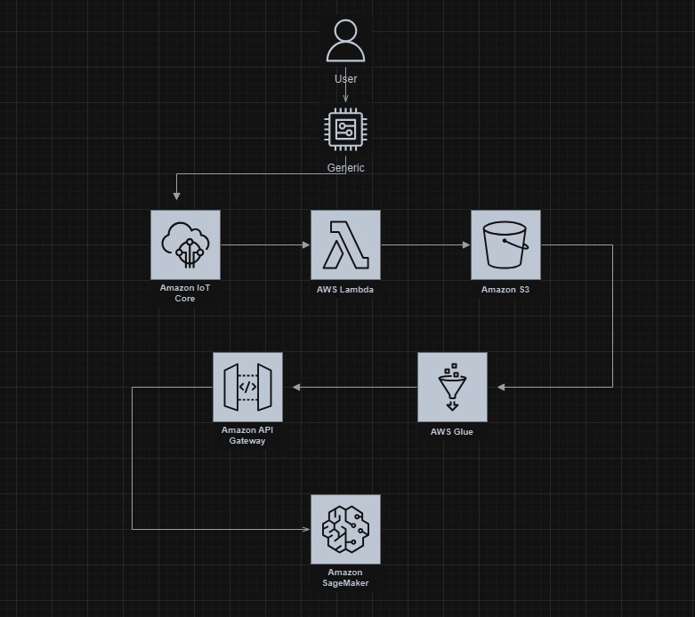
Option 2:
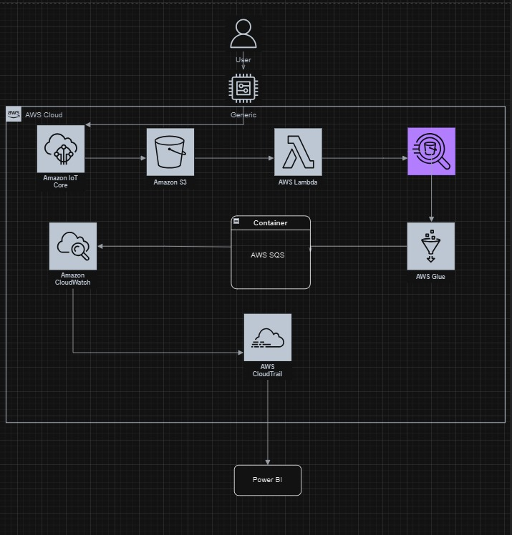
Option 3 :
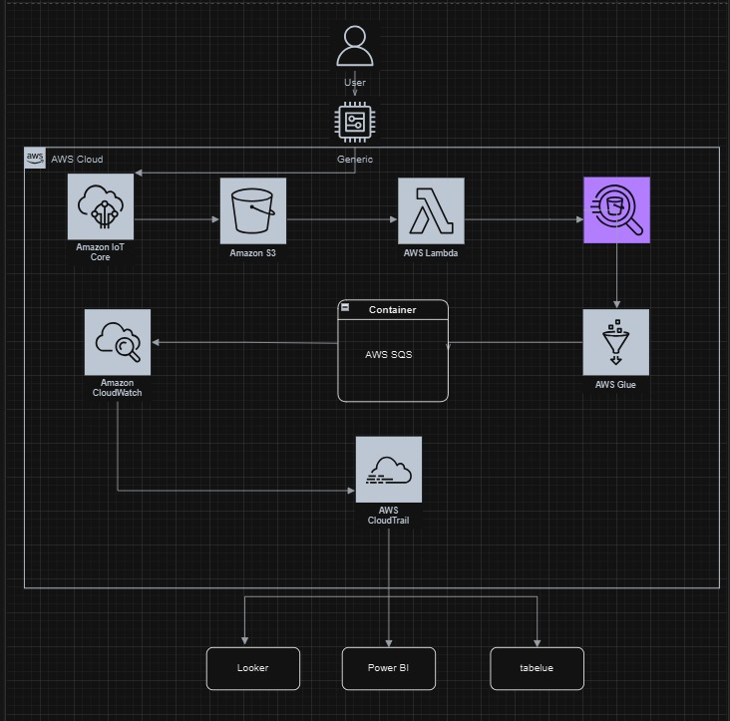

Amazon IoT Core
Purpose:
Amazon IoT Core is the entry point for data ingestion from IoT devices, including my M5Stack Core2. It securely connects the device to AWS, allowing for real-time data transmission, storage, and analysis.
Technical Advantage:
IoT Core supports scalable, low-latency data collection, and can handle large volumes of device messages. It supports MQTT protocol, well-suited for lightweight, low-power IoT devices, and provides secure connectivity to prevent unauthorized access.
Business Value:
Real-time data collection enables proactive decision-making. This is especially useful for monitoring temperature and humidity for plants, as quick responses are necessary to maintain ideal growth conditions. It adds value by minimizing manual monitoring, reducing operational costs, and increasing productivity.

Amazon S3 (Simple Storage Service)
Purpose:
S3 serves as the storage layer, where all IoT data from the M5Stack Core2 is archived. It acts as a repository for raw data, making it accessible for further processing and analysis.
Technical Advantage:
S3 provides highly durable and scalable storage at low cost. It can store vast amounts of data, including raw, semi-processed, or fully analyzed data, in a structured format. It also integrates well with other AWS services, which facilitates easy data access and retrieval.
Business Value:
By archiving historical data, Amazon S3 enables long-term trend analysis, helping to understand and optimize conditions over time. This information can lead to better resource management and contributes to sustainable and efficient operations.

AWS Lambda
Purpose:
AWS Lambda processes data in response to specific events. When new data is uploaded to S3, Lambda functions are triggered to clean, format, and enrich the data, preparing it for further analysis.
Technical Advantage:
Lambda enables serverless, on-demand data processing, which reduces infrastructure overhead. It scales automatically and only incurs cost when active, optimizing resource usage and allowing for flexible, real-time data manipulation.
Business Value:
Lambda’s event-driven architecture reduces the need for dedicated servers, which lowers operational costs and improves data processing efficiency. It enables faster data preparation, allowing timely insights that can support critical decision-making.

AWS Athena
Purpose:
Athena provides serverless SQL querying on the data stored in S3. This service allows users to run complex queries directly on the data without the need for loading it into a separate database.
Technical Advantage:
Athena supports ad hoc querying without the need for infrastructure setup or maintenance. It can handle structured data formats like CSV or Parquet, making it easy to explore and analyze data directly within S3.
Business Value:
Athena’s SQL-based access to data allows for quick, cost-effective analysis without additional processing steps. This empowers business users to make data-driven decisions without needing extensive technical skills, promoting data accessibility across the organization.

AWS Glue
Purpose:
AWS Glue is used for ETL (Extract, Transform, Load) tasks, creating data catalogs, and data preparation. Glue organizes, cleans, and transforms data, making it ready for querying and analysis.
Technical Advantage:
Glue automates data preparation by handling schema discovery and transforming raw data into structured datasets. It integrates seamlessly with Athena and other AWS services, streamlining the data processing pipeline.
Business Value:
With Glue, data preparation is automated, reducing manual data handling and accelerating time-to-insight. Clean, organized data contributes to accurate analysis, which is essential for effective decision-making and operational efficiency.

AWS SQS (Simple Queue Service)
Purpose:
SQS decouples data processing tasks by queuing messages between different stages of the pipeline. This ensures reliable and ordered delivery of data, even under high loads.
Technical Advantage:
SQS ensures smooth data flow by managing message queues, which helps to maintain consistency and prevent data loss. It offers scalability and resilience, improving the robustness of the entire pipeline.
Business Value:
By buffering data, SQS helps the system handle bursts of data without affecting processing performance. This reliability ensures consistent data flow, which minimizes downtime and supports uninterrupted data insights, essential for operational continuity.

Amazon CloudWatch
Purpose:
CloudWatch monitors and logs the performance and status of various services in the pipeline, tracking metrics like data throughput and system errors.
Technical Advantage:
CloudWatch provides real-time insights into system health, alerting administrators to any issues that might require immediate attention. It can create dashboards and automate alerts, enhancing system reliability.
Business Value:
Monitoring ensures the pipeline operates efficiently, reducing the likelihood of unplanned downtime. CloudWatch’s alerts allow for proactive problem-solving, helping to maintain service levels and ultimately reducing operational costs.

AWS CloudTrail
Purpose:
CloudTrail records all API requests made across AWS services, providing detailed logging for security, compliance, and operational auditing.
Technical Advantage:
CloudTrail enables visibility into the actions taken on AWS resources. It tracks changes and ensures all interactions with data are logged for accountability and transparency.
Business Value:
For businesses, CloudTrail’s auditing capabilities support compliance requirements and enhance security measures. This traceability reassures stakeholders about data governance, fostering trust in the organization’s data practices.

Analysis Tools: Looker, Power BI, Tableau
Purpose:
These analysis tools visualize data trends and patterns, turning processed data into insights through interactive dashboards and reports.
Technical Advantage:
Each tool has unique visualization capabilities, making complex datasets easier to interpret. These tools integrate with AWS data sources, enabling real-time visualization.
Business Value:
Visualizations allow decision-makers to quickly interpret data, supporting data-driven strategies. This enhances strategic planning and supports operational improvements by making insights accessible to a wide audience, including non-technical users.

AWS IOT connection to AWS s3 bucket
The steps taken for these connections are as follows:
- Once the AWS connection with the iot is confirmed we will move on to the next component. Connecting AWS S3 with AWS IOT.
- Open up AWS Learner Lab, Go to AWS S3, Upon entering using the nav bar on the left we will go to “Buckets” which will lead you to this page. Click “create bucket” we will be making a bucket to store the data from the IOT. 